TFTP File Transfer System
Team 17

Aaron Hill
Brandon Keyes
Jason Bromfield
Ihtisham Mazhar
Remy Gratwohl
Table of Contents
Setup
Configuration
Diagrams
Files
Team Member Contributions

Setup
Import the project folder into Eclipse, and run the Server.java, followed by ErrorSimulator.java, and finally Client.java in that specific order.

Configuration
Config File
The config file contains many modifiable values:
USE_ERR_SIM
- Enable/Disable using the error simulator.
DEFAULT_MODE
- The default transfer mode used.
MAX_BYTE_ARR_SIZE
- Maximum size of the byte arrays in bytes.
MAX_PAYLOAD_SIZE
- Maximum size of the payload in bytes
MAX_PRINT_SIZE
- Length of the print statements.
MAX_TIMEOUT
- The socket timeout in milliseconds.
MAX_TRANSMITS
- The number of times the client/server should retransmit
PRINT_PACKETS
- Enable/Disable more verbose packet logging.

Error Simulation
The error simulator has a console where the user can select different errors to simulate. There are packet errors and network errors.

Below are numerical values corresponding to different forms of error simulation that can be found in the ErrorSimulator class.

The ErrorSimulator will prompt for one packet error at start, allowing the user to select which packets to corrupt and how to corrupt them.

0 - DEFAULT_MODE
- Does not touch the packets and simply passes them through.
1 - CORRUPT_OPERATION_MODE
- Changes the opcode of a packet to an invalid one.
2 - CORRUPT_DATA_BLOCK_NUM_MODE
- Changes the block number of data packets to something invalid.
3 - REMOVE_BLOCK_NUM_MODE
- Splices the block number of data and ack packets to something invalid.
4 - CORRUPT_CLIENT_TRANSFER_ID_MODE
- Sends the packet to the server from a diffenent port, meaning a different TID.
5 - CORRUPT_SERVER_TRANSFER_ID_MODE
- Sends the packet to the client from a diffenent port, meaning a different TID.
6 - APPEND_PACKET_MODE
- Adds another corrupt byte to the end of a packet's byte array.
7 - SHRINK_PACKET_MODE
- Removes the last byte at the end of a packet's byte array.
8 - CORRUPT_FILENAME_MODE
- Reverses the filename of a RRQ/WRQ, invalidating it.
9 - CORRUPT_TRANSFER_MODE
- Reverses part of the RRQ/WRQ transfer mode, invalidating it.
10 - CORRUPT_FILENAME_DELIMITER_MODE
- Moves the 0 delimeter between the filename and the transfer mode in RRQ/WRQ packets.
11 - CORRUPT_TRANSFER_DELIMITER_MODE
- Moves the 0 delimeter between the transfer mode and the data in RRQ/WRQ packets.
12 - REMOVE_FILENAME_MODE
- Removes the filename from a RRQ/WRQ packet.
13 - REMOVE_TRANSFER_MODE
- Removes the transfer mode from a RRQ/WRQ packet.
14 - REMOVE_FILENAME_DELIMITER_MODE
- Removes the 0 delimeter between the filename and transfer mode in RRQ/WRQ packets.
15 - REMOVE_TRANSFER_DELIMITER_MODE
- Removes the 0 delimeter between the transfer mode in RRQ/WRQ packets.
16 - CORRUPT_DATA_MODE
- Scrambles any packet's data byte array.
17 - REMOVE_DATA_MODE
- Removes a packet's data byte array.
18 - CORRUPT_ACK_BLOCK_NUM_MODE
- Changes the block number of ack packets to something invalid.
19 - GROW_DATA_EXCEED_SIZE_MODE
- Removes all data from the packet, left with the opcode
20 - CORRUPT_DATA_OPERATION_MODE
- Changes the opcode of a data packet to something invalid.
21 - CORRUPT_ACK_OPERATION_MODE
- Changes the opcode of an ack packet to something invalid.

It will also prompt for a Network Simulation mode, which are listed below.

0 - DEFAULT_MODE
- Creates no errors in the network connection.
1 - LOSE_RRQ_PACKET_MODE
- Loses the speceified RRQ packet.
2 - LOSE_WRQ_PACKET_MODE
- Loses the speceified WRQ packet.
3 - LOSE_DATA_PACKET_MODE
- Loses the speceified DATA packet.
4 - LOSE_ACK_PACKET_MODE
- Loses the speceified ACK packet.
5 - LOSE_ERROR_PACKET_MODE
- Loses the speceified ERROR packet.
6 - DELAY_RRQ_PACKET_MODE
- Delays the specified RRQ packet.
7 - DELAY_WRQ_PACKET_MODE
- Delays the specified WRQ packet.
8 - DELAY_DATA_PACKET_MODE
- Delays the specified DATA packet.
9 - DELAY_ACK_PACKET_MODE
- Delays the specified ACK packet.
10 - DELAY_ERROR_PACKET_MODE
- Delays the specified ERROR packet.
11 - DUPLICATE_RRQ_PACKET_MODE
- Duplicates the specified RRQ packet.
12 - DUPLICATE_WRQ_PACKET_MODE
- Duplicates the specified WRQ packet.
13 - DUPLICATE_DATA_PACKET_MODE
- Duplicates the specified DATA packet.
14 - DUPLICATE_ACK_PACKET_MODE
- Duplicates the specified ACK packet.
15 - DUPLICATE_ERROR_PACKET_MODE
- Duplicates the specified ERROR packet.

Shutdown
Typing 'shutdown' into the Server class' console will terminate it after all current transfers have completed it.

File Storage
By default, files transfered will be stored in the following locations:
Server: "src/Main/ServerStorage"
Client: "src/Main/ClientStorage"
** The storage folder for the Client is created automatically when the system is run, but you must create the storage folder for the Server manually. **

** This system overrites files that already exist in the destination's storage folder. **
Diagrams
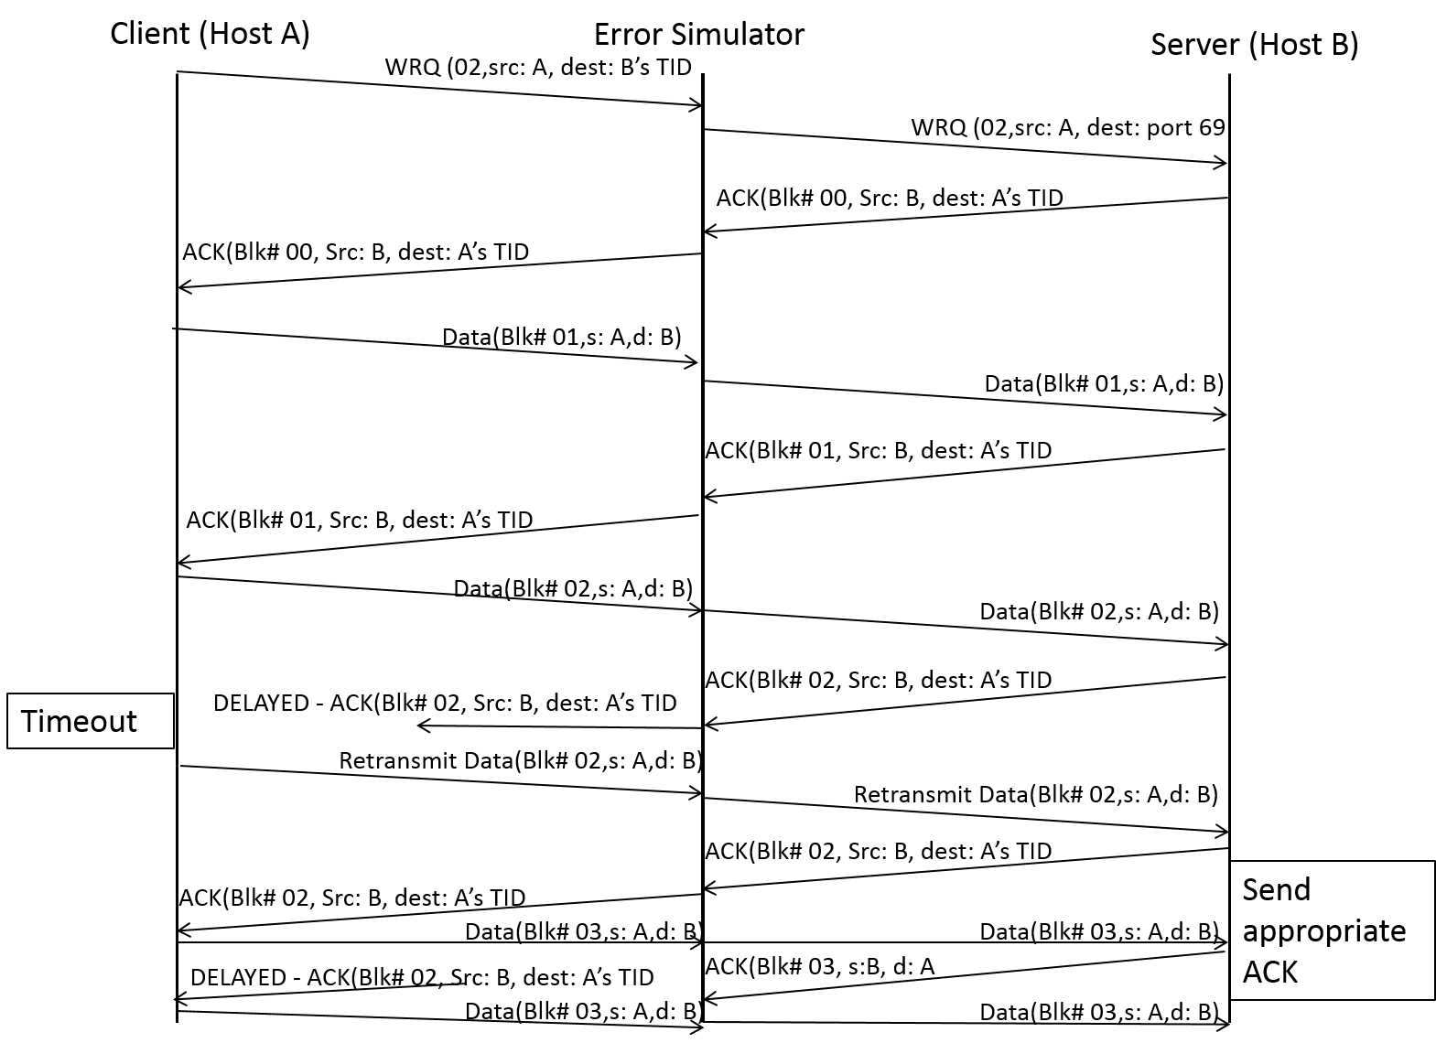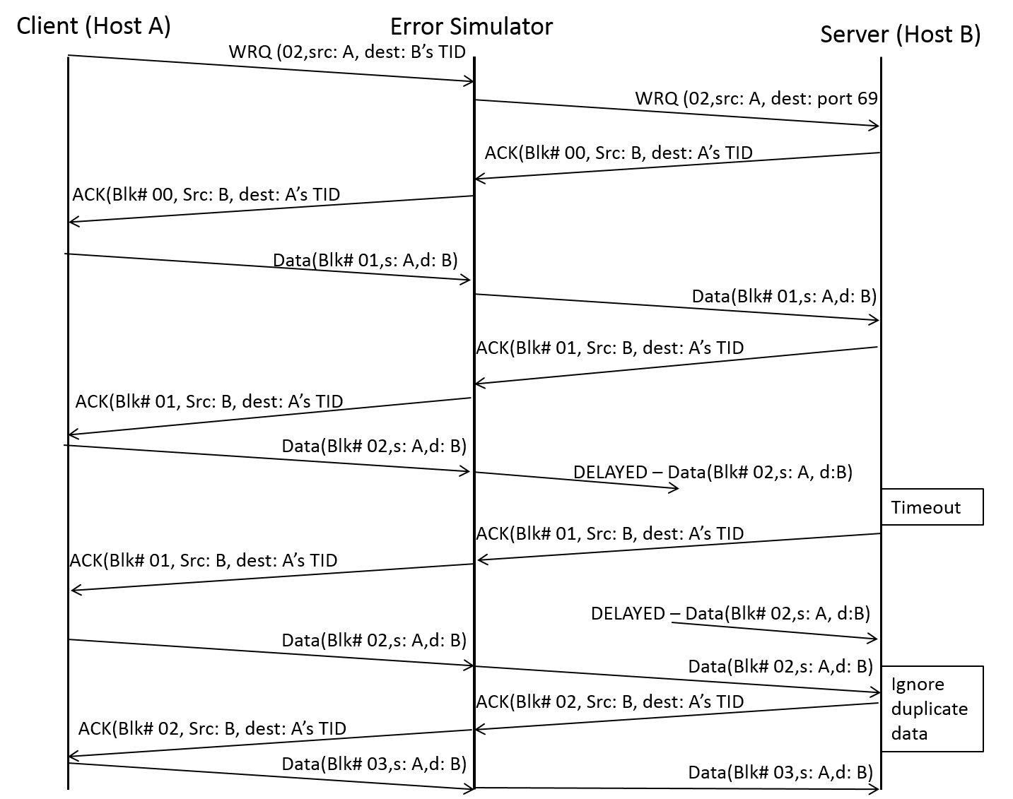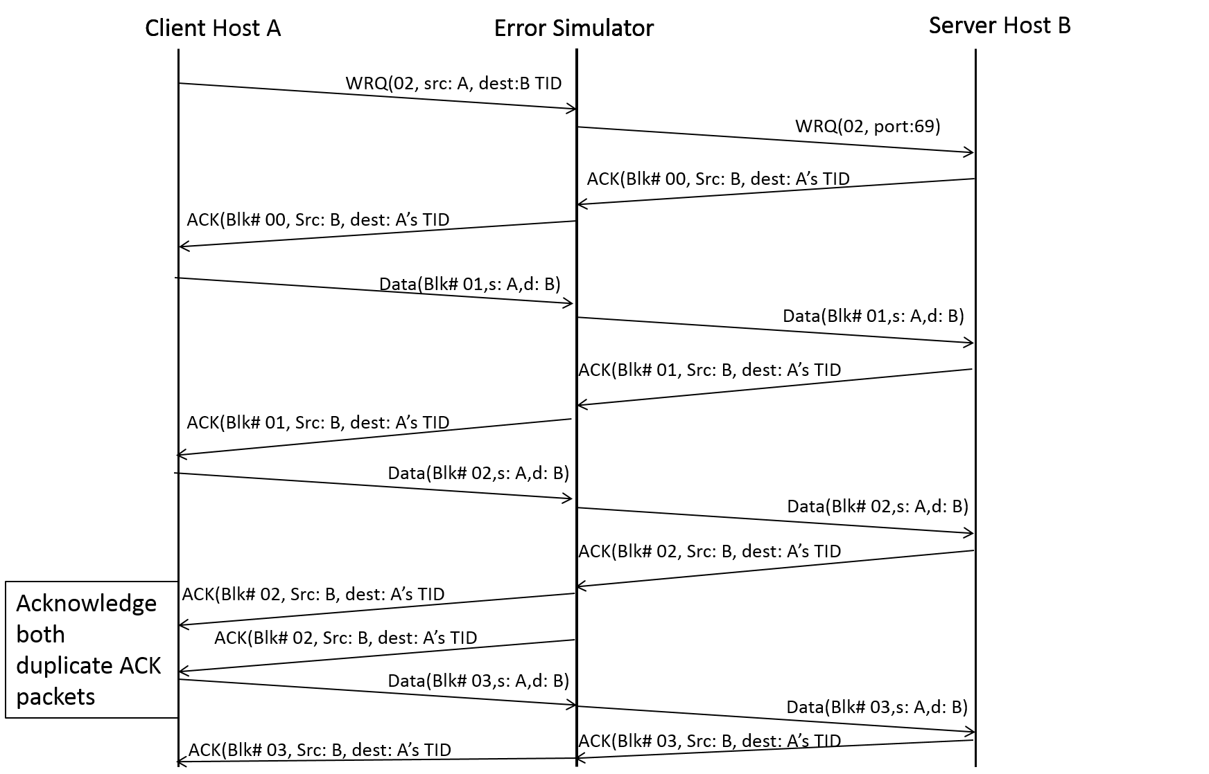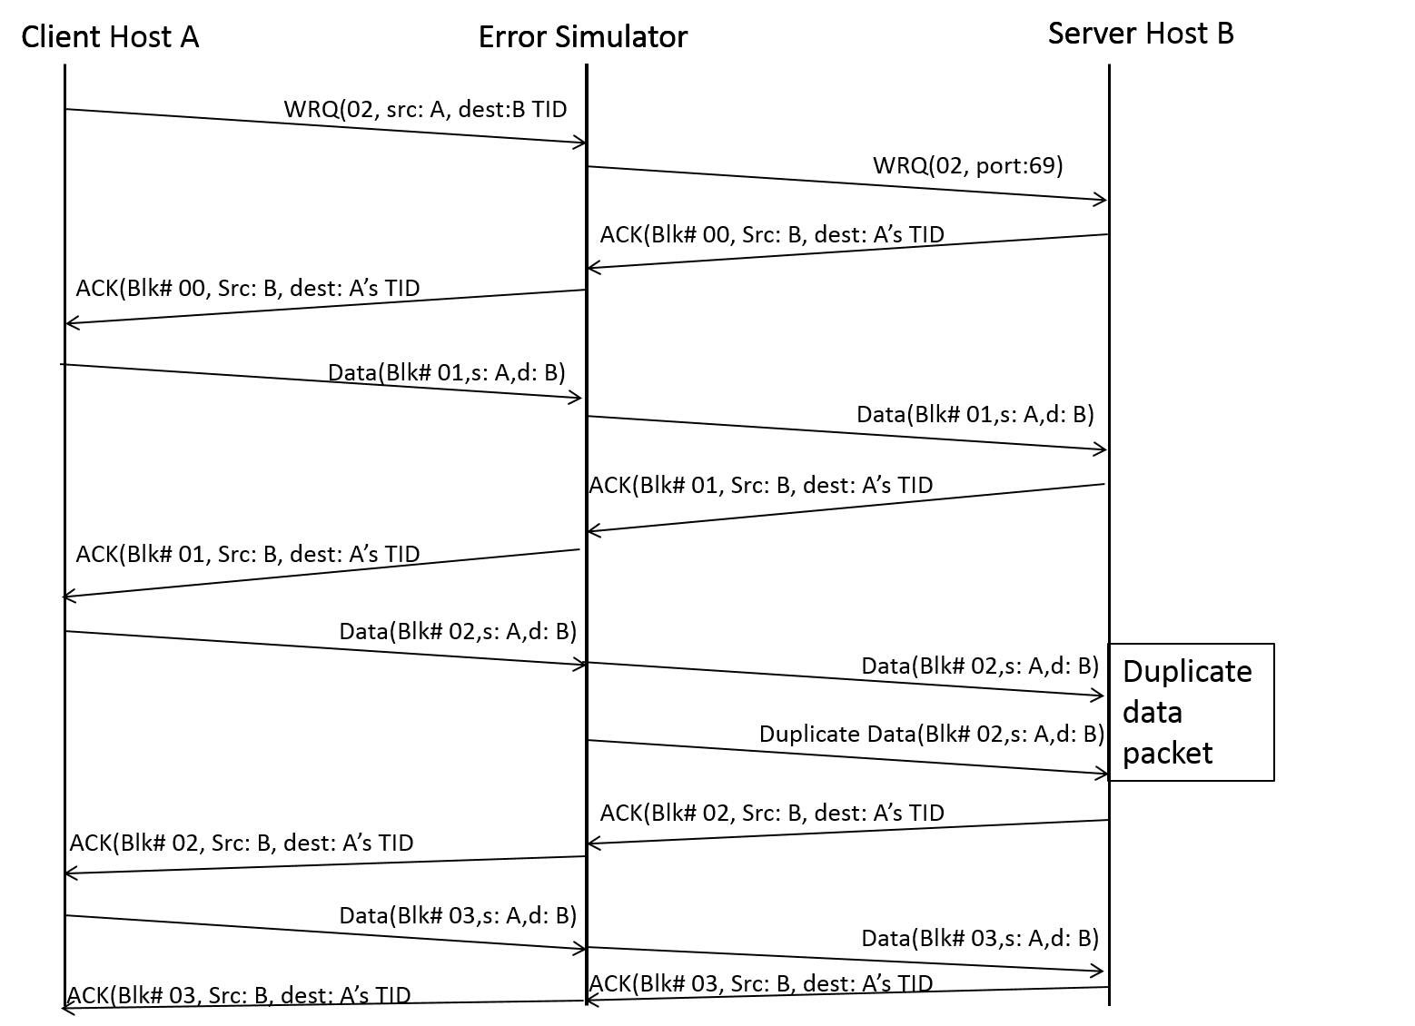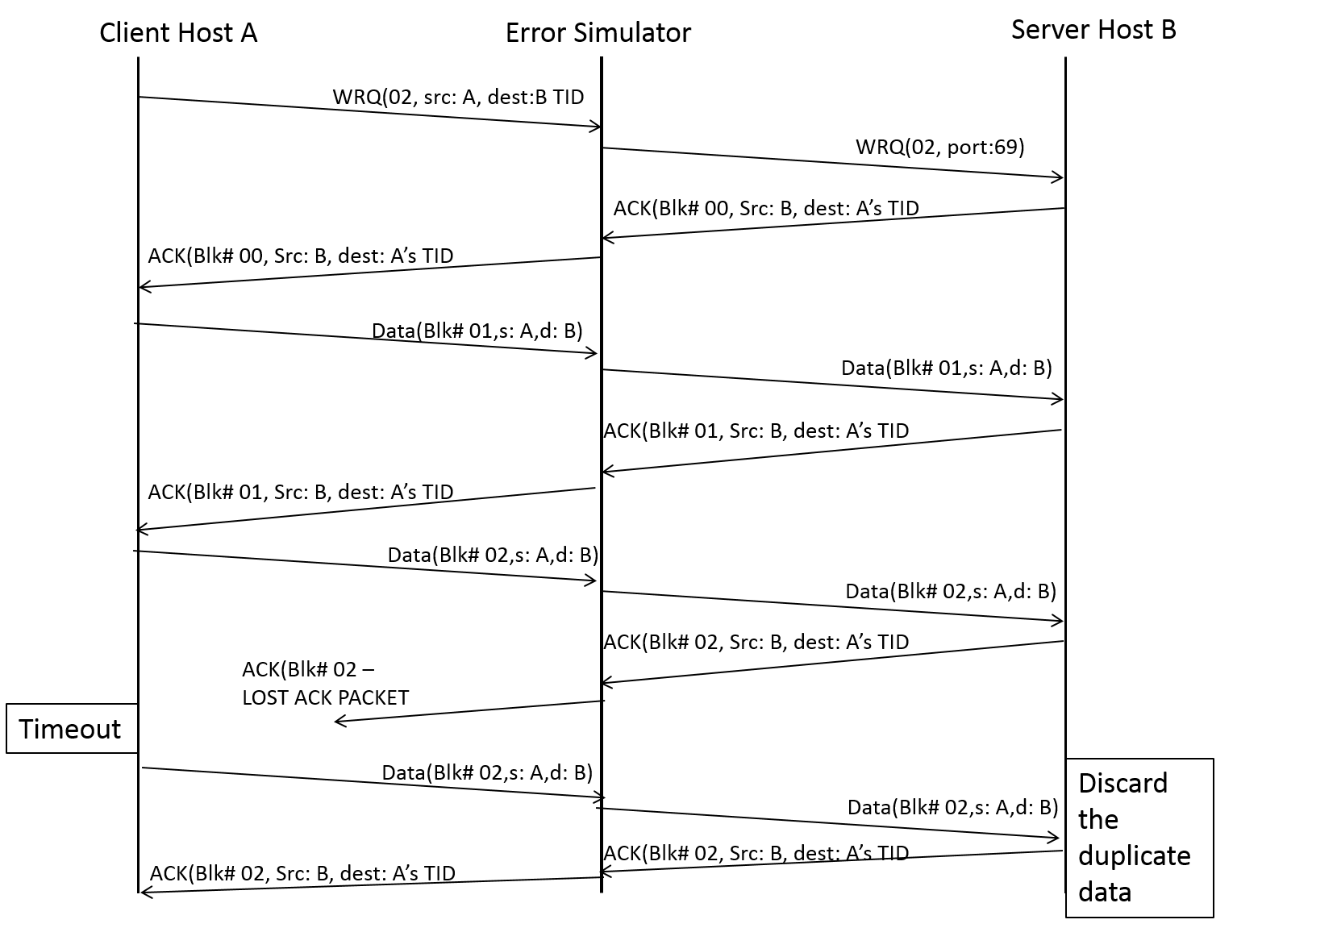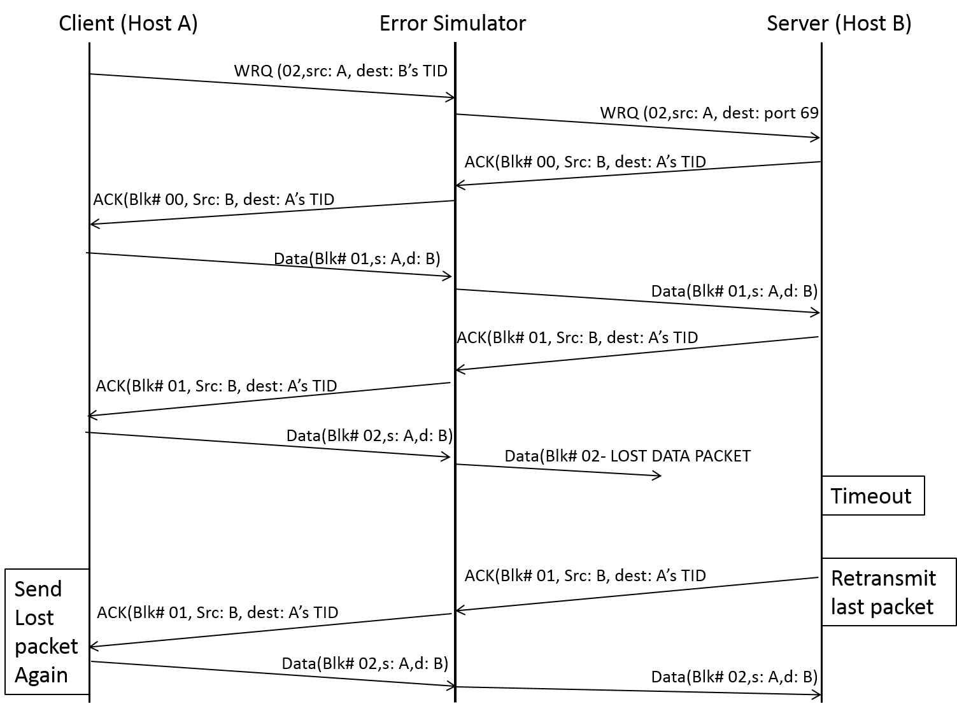
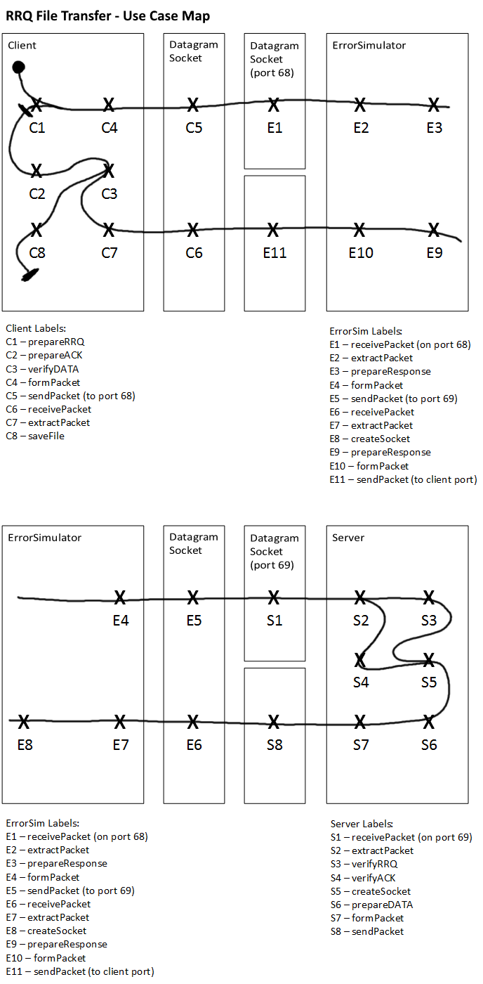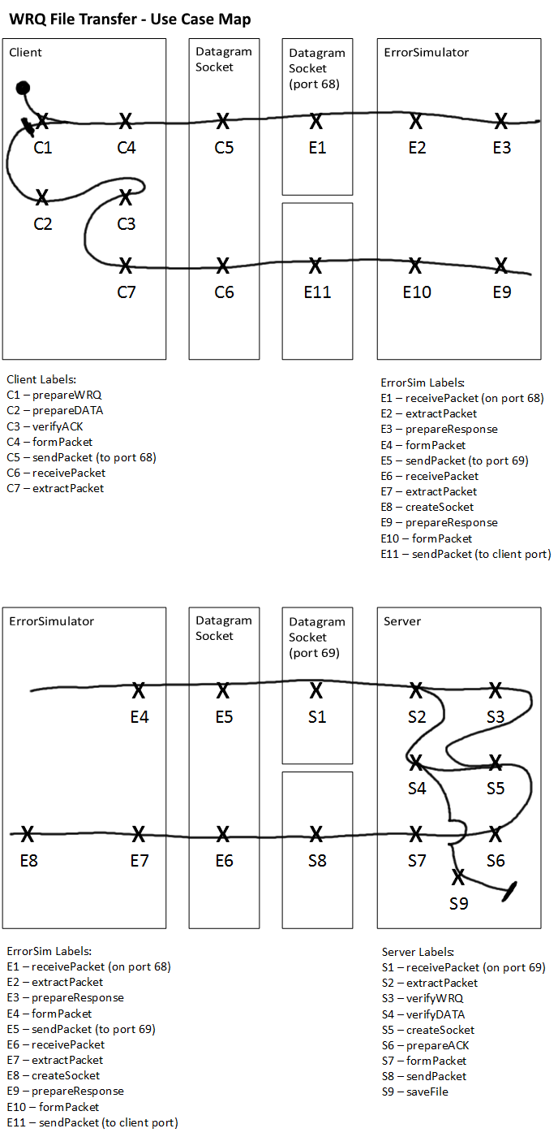
Files
Client.java
- A client that can read and write files to and from the server.

ErrorSimulator.java
- Creates various errors in the transfer between the client and server, for testing purposes

Server.java
- A server that can send and recieve files to and from clients that request them.

AckPacketParser.java
- Parses TFTP ACK packets

DataPacketParser.java
- Parses TFTP DATA packets

ErrorPacketParser.java
- Parses TFTP Error packets

RequestPacketParser.java
- Parser for TFTP RRQ/WRQ packets

PacketParser.java
- Super class for all the PacketParser classes

TransferMode.java
- Enum containing the different transfer modes (Netascii/Octet)

ErrorCode.java
- Enum containing the various error codes

Operation.java
- Enum containing the different TFTP OPcodes

Config.java
- File storing configuration parameters

NetworkConnector.java
- Encapsulates network connection needed to send/receive packets

PacketReader.java
- Parses and prints packet information

NetworkSimulationMode.java
- Enum containing the various error simulation modes

PacketSimulationMode.java
- Enum containing the various error simulation modes

FileServer.java
- Encapuslates writing and reading files from disk

ClientLink.java
- Overrides the run() function in Link
- Represents a threaded connection between the Client and the ErrorSimulator

Link.java
- Handles packet and network errors for the ClientLink and ServerLink classes

ServerLink.java
- Overrides the run() function in Link
- Represents a threaded connection between the ErrorSimulator and the Server

Team Member Contributions
Iteration 0 and Iteration 1
Brandon: NetworkConnector, PacketReader, Use Case Maps, minor stuff in Server/ErrorSim.
Jason: Server, README.
Aaron: Client, README.
Mazhar: ErrorSim, UML Class Diagram.
Remy: All PacketParsers, minor stuff in Server/Client.

Iteration 2
Brandon: Corrupter functions 1-8 in ErrorSimulator, shutdown Server nicely, Client/Server error generation/handling.
Jason: Diagrams, README.
Mazhar: Corrupter functions 9-17 in ErrorSimulator, extensive test menu in ErrorSimulator.
Aaron: Client/Server system printing standardization, file/IO class for the Client/Server.
Remy: Modify PacketParser functions to take in the byte array length, Implement the ErrorPacketParser.

Iteration 3
Brandon: Handling duplicated packets.
Jason: Handling delayed and lost packets, README.
Mazhar: Diagrams.
Aaron: Handling timeouts.
Remy: Bugfixes, Miscellaneous clean up.

Iteration 4
Brandon: Major code fixups.
Jason: Handling error code 1, minor code fixups.
Mazhar: Diagrams, handling error code 3.
Aaron: Handling error codes 2 and 6.
Remy: Diagrams.

Iteration 5
Brandon: Implemented selecting a packet for packet error simulator, making the corruption of opcodes more robust.
Jason: Implemented selecting a destination IP address.
Mazhar: Implemented printing duplicate packet messages.
Aaron: Updated error message format, implemented selecting destination IP address at any time outside of during a file transfer, implemented selecting to run in test mode.
Remy: Updated documentation.

